Nicholas Skinner

CS 453

Spring 2019

**Project #7: ParaView Terrain Visualization**

**Map:**

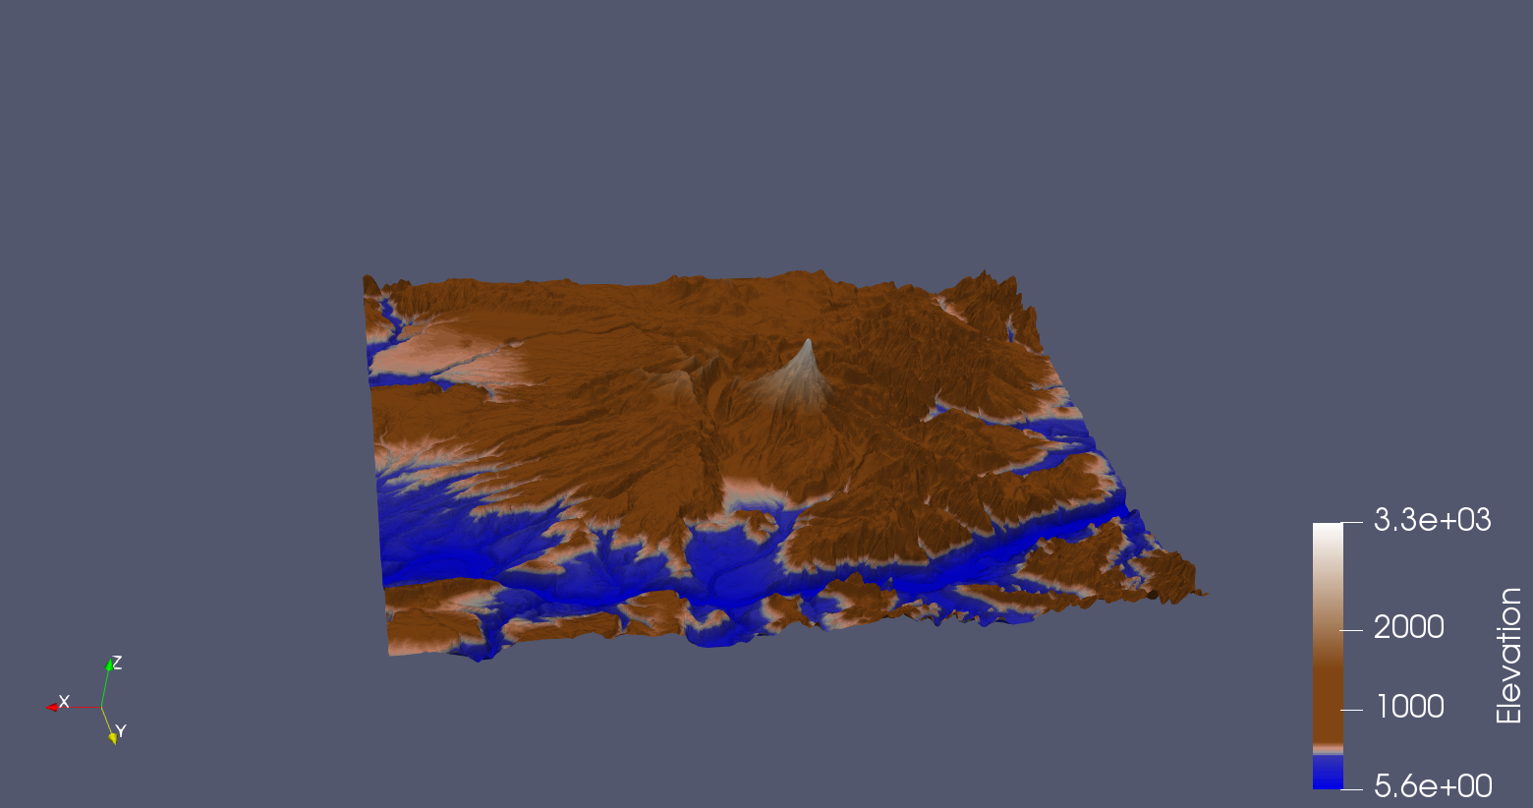

**Contours:**

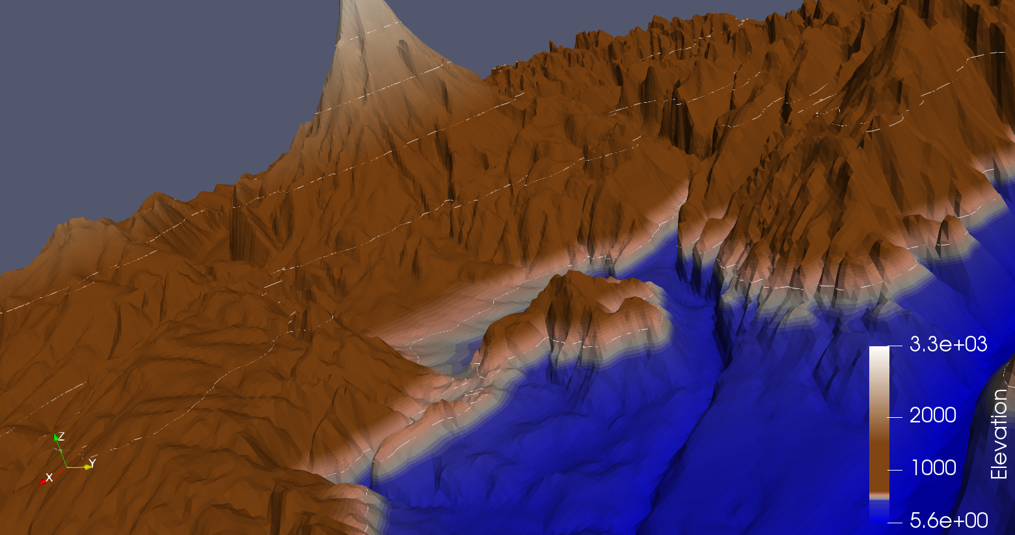

**Left/Right Eye:**

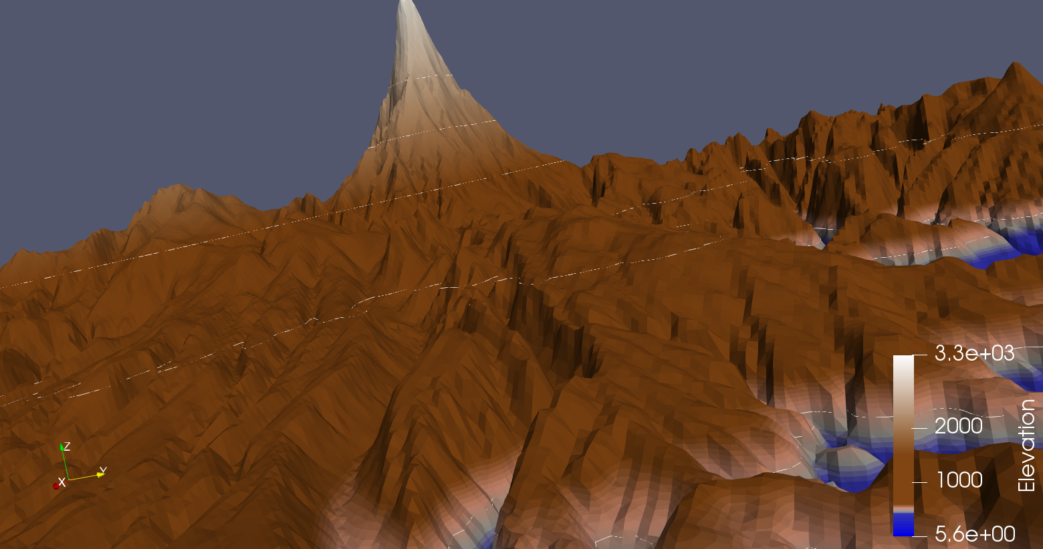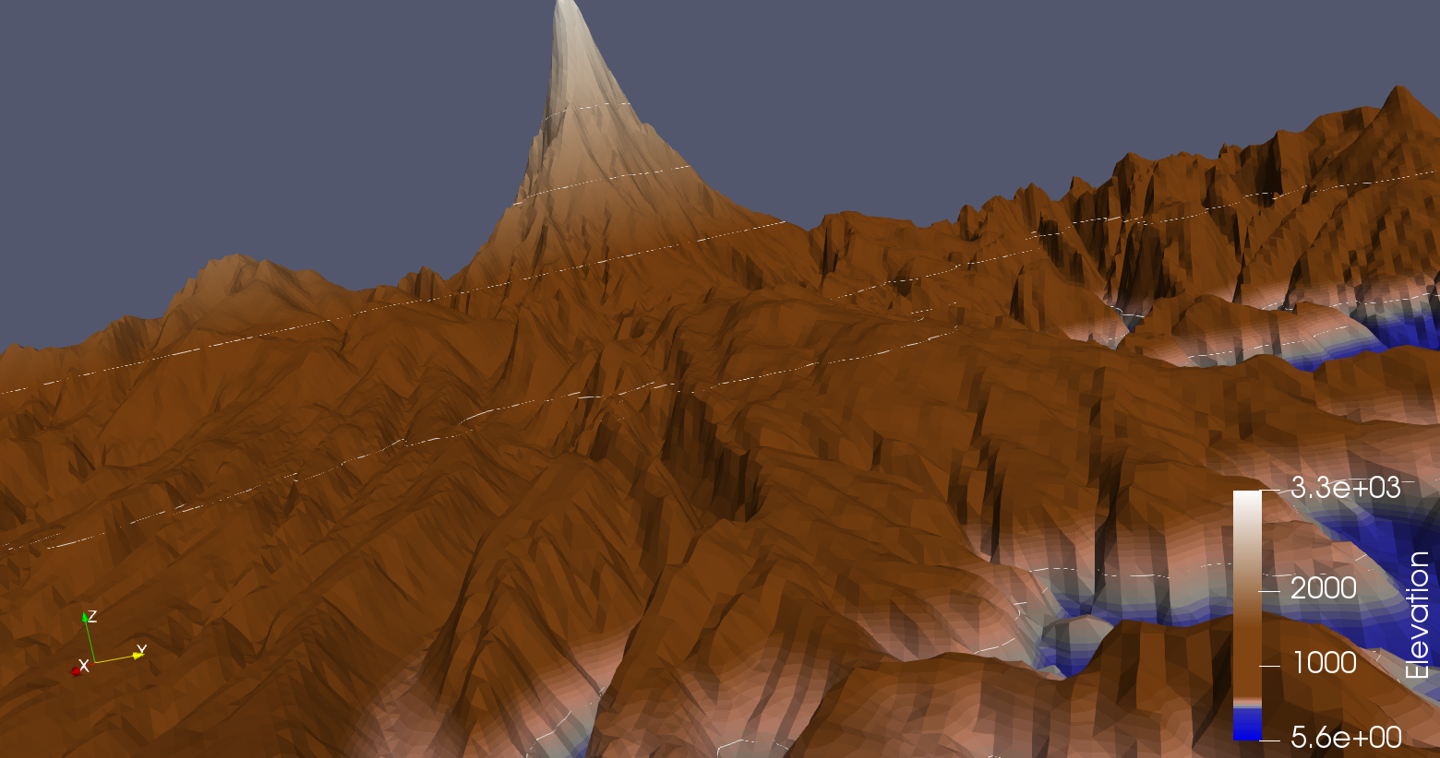

**Commentary:**

I didn’t end up doing any custom height exaggeration, as I felt for this project, the data is already exaggerated enough. We can tell where the different crevices and peaks are on all the terrain, and I didn’t need to do any customization to get there. I’ve put a side by side of the standard height vs doubling the height.

**Without height exaggeration:**

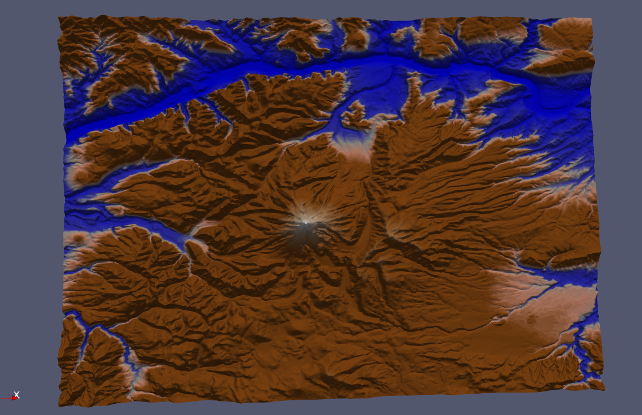

**With height exaggeration:**

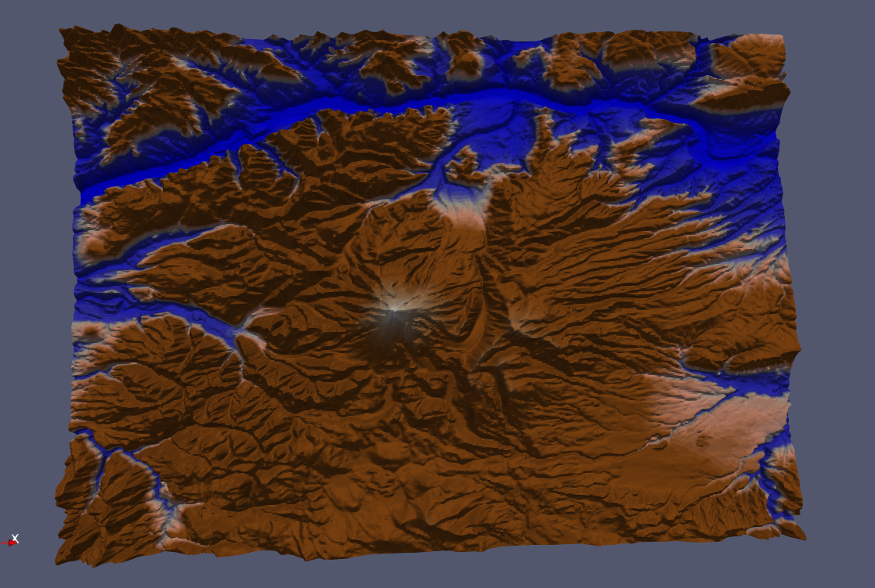

On the monitor, there's a good amount of depth that is added to the image through adding this height, and it looks really good from a top-down angle, there also appears to be a greater color contrast from the exaggerated height mapping, but I can’t help but like the more vibrant color scheme that the standard representation gives us.

I’m colorblind, so I hope I got the color transformations mostly correct, brown is a really hard color to get looking right! In my screenshots I tried to show off all my major features, but the contour lines were somewhat difficult to get good screenshots of.

I made the areas that are adjacent to water slightly lighter than the rest of the hills, as it looks somewhat realistic to have lighter areas around bodies of water.

Video: <https://media.oregonstate.edu/media/0_sdv0nikv>